|  |
| --- |
| **Neha Malhotra**  **R.L. Institute M: 9416974837**  **Class : XI**  **“ANIMAL KINGDOM”** |

**Level – 1**

**(Based on Basis of Classification and**

**Porifera , Coelentereta , Ctenophora , Platyhelminthes & Aschelminthes Phylum)**

1. Which of the following is not a characteristics feature of kingdom Animalia?

|  |  |
| --- | --- |
| a) Storage of carbohydrates as starch | b) Multicellularity |
| c) Obtaining nutrients by ingestion | d) Having eukaryotic cells without walls |

1. Which of the following is not the common fundamental feature for animal classification?

|  |  |
| --- | --- |
| a) Germinal layers | b) Pathway of water transport |
| c) Pattern of organization of cells | d) Serial repetition of the segments |

1. Which one of the following organisms is diploblastic?

|  |  |  |  |
| --- | --- | --- | --- |
| a) *Pennatula* | b) *Paramoecium* | c) *Polystomella* | d) *Entamoeba* |

1. Which group contains animals that are not pseudo coelomate?

|  |  |
| --- | --- |
| a) *Enterobius , Wuchereria* | b) *Ascarias , Ancyclostoma* |
| c) *Ancyclostoma , Dracunculus* | d) *Planaria , Taenia* |

1. The adults are radially symmetrical but larvae exhibit bilateral symmetry is :

|  |  |  |  |
| --- | --- | --- | --- |
| a) Mollusca | b) Hemichordata | c) Echinodermata | d) Cephalochordata |

1. Pseudocoelom found in :

|  |  |  |  |
| --- | --- | --- | --- |
| a) *Ascarias* | b) *Hydra* | c) *Taenia* | d) *Leucosolenia* |

1. Which one of the following groups of animals is bilaterally symmetrical and triploblastic?

|  |  |  |  |
| --- | --- | --- | --- |
| a) Sponges | b) Coelenterates | c) Aschelminthes | d) Ctenophores |

1. Diploblastic and Triploblastic are terms that describe :
2. The number of invaginations during embryonic development.
3. The number of heads during embryonic development.
4. The number of germinal layers during embryonic development
5. The number of cell types during development.

ANIMAL KINGDOM Page No. 1

1. Cellular grade of organization is found in :

|  |  |  |  |
| --- | --- | --- | --- |
| a) Helminthes | b) Coelenterate | c) Porifera | d) all of these |

1. Animals with metameric segmentation, bilateral symmetry and closed circulatory system belongs to phylum:

|  |  |  |  |
| --- | --- | --- | --- |
| a) Annelida | b) Echinodermata | c) Arthropoda | d) Mollusca |

1. Which one of the sponges part corresponds to the mouth of other animals?

|  |  |  |  |
| --- | --- | --- | --- |
| a) osculum | b) Incurrent canal | c) Ostia | d) Excurrent canal |

1. ‘Portuguese man of war’ refers to :

|  |  |
| --- | --- |
| a) Soldier of world war I | b) Portuguese soldier |
| c) A sponge | d) A polymorphic, colonial coelenterate |

1. Characteristics free swimming larva of coelenterates is :

|  |  |  |  |
| --- | --- | --- | --- |
| a) Onchosphere | b) Hydrula | c) Planula | d) Amphiblastula |

1. Ctenophores have similarities with members of :

|  |  |  |  |
| --- | --- | --- | --- |
| a) Porifera | b) Coelenterate | c) Arthropoda | d) Annelida |

1. Amphiblastula is larva of :

|  |  |  |  |
| --- | --- | --- | --- |
| a) Leucosolenia | b) Clathrina | c) Sycon | d) Both (a) and (b) |

1. Elephantiasis is caused by :

|  |  |  |  |
| --- | --- | --- | --- |
| a) Trichinella | b) Desmoscolex | c) Enterobius | d) Wuchereria |

1. Planaria , liver fluke and Taenia solium are :

|  |  |
| --- | --- |
| a) All segmented | b) All found in the gut |
| c) All have coelom | d) All are flatworms |

1. A rhabditiform larva is formed in the life cycle of :

|  |  |  |  |
| --- | --- | --- | --- |
| a) Ascarias | b) Tapeworm | c) Hydra | d) Leucosolenia |

1. Which of the following statements is/are correct?
2. Organ system in different group of animals show various patterns of complexities.
3. The digestive system, in Platyhelminthes has only a single opening to the outside of the body that serve as both mouth and anus and is hence called complete.
4. In open type of circulatory system, the blood is pumped out of the heart and the cells and tissues are directly bathed in it.
5. In closed type, the blood is circulated through a series of vessels of varying diameters (arteries, veins and Capillaries).

|  |  |  |  |
| --- | --- | --- | --- |
| a) (i) | b) (ii) and (iii) | c) (i) , (ii) and (iii) | d) all of these |

1. Which of the following statements is/are correct regarding phylum Coelenterata?
2. They are aquatic, mostly marine , sessile or free-swimming , radially symmetrical animals
3. They have a central gastro-vascular cavity with a single opening called Hypostome.
4. Digestion is extracellular and intracellular.
5. Examples : Sycon , Spongilla and Euspongilla

|  |  |  |  |
| --- | --- | --- | --- |
| a) (i) and (ii) | b) (i) and (iv) | c) (i) , (ii) and (iii) | d) all of these |

ANIMAL KINGDOM Page No. 2

1. Which of the following statements is without exception in sponges?

|  |  |
| --- | --- |
| a) They all have calcareous spicules | b) They have high regeneration power |
| c) They are found only in marine water | d) They are all radially symmetrical. |

1. Refer the following statement and answer the question.

Name of “X” is derived from stinging capsules. It exhibits metagenesis containing two body forms in which sessile and cylindrical form is called “Y” and umbrella shaped and free swimming called “Z”. Identify X , Y and Z.

1. X = Coelenterate ; Y = Polyp ; Z = Medusa
2. X = Cnidarian ; Y = Medusa ; Z = Polyp
3. X = Ctenophora ; Y = Radula ; Z = Hypostome
4. X = Porifera ; Y = Osculum ; Z = Radula
5. Read the following statement and identify the correct phylum.
6. They are exclusively marine, radially symmetrical , diploblastic organisms with tissue level of organization.
7. Body bears 8 external rows of ciliated comb plates, which help in locomotion.
8. Digestion is both extracellular and intracellular
9. Reproduction takes place only by sexual means.

|  |  |  |  |
| --- | --- | --- | --- |
| a) Platyhelminthes | b) Arthropoda | c) Mollusca | d) Ctenophora |

1. Match column I and column II

|  |  |  |
| --- | --- | --- |
| Column I | Column II | |
| A. Ascus | I. Spirulina | |
| B. Basidium | II. Penicillium | | |
| C. Protista | III. Agaricus | |
| D. Cyanobacteria | IV. Euglena | |
| E. Animalia | V. Sponges | |
| a) A – II ; B – III ; C – IV ; D – V ; E – I | | | b) A – I ; B – II ; C – III ; D – V ; E – IV | | |
| c) A – II ; B – V ; C – III ; D – I ; E – IV | | | d) A – II ; B – III ; C – IV ; D – I ; E – V | | |

1. Which of the following statements is/are correct regarding phylum Aschelminthes?
2. The body is circular in cross-section hence the name round worm.
3. Alimentary canal is complete with a well-developed muscular pharynx.
4. Sexes are separate (dioecious)
5. Nephridia help in osmoregulation and excretion

|  |  |  |  |
| --- | --- | --- | --- |
| a) (i) and (ii) | b) (iii) and (iv) | c) (i) , (ii) and (iii) | d) all of these |

1. Consider following features :

(i) Organ system of organization (ii) Bilateral symmetry (iii) True coelomates

Select the correct option of animal groups which possess all the above features :

|  |  |
| --- | --- |
| a) Annelida , Arthropoda , Chordata | b) Annelida , Arthropoda , Mollusca |
| c) Arthropoda , Mollusca , Chordata | d) Annelida , Mollusca , Chordata |

ANIMAL KINGDOM Page No. 3

1. In case of poriferans, the spongocoel is lined by flagellated cells called :

|  |  |  |  |
| --- | --- | --- | --- |
| a) Oscula | b) Choanocytes | c) Mesenchymal cells | d) ostia |

1. Metagenesis refers to :
2. Alternation of generation between asexual and sexual phases of an organism.
3. Occurrence of a drastic change in form during post-embryonic development.
4. Presence of a segmented body and parthenogenetic mode of reproduction.
5. Presence of different morphic forms
6. Body having meshwork of cell, internal cavities lined with food filtering flagellated cells and indirect development are the characteristics of phylum__________.

|  |  |  |  |
| --- | --- | --- | --- |
| a) Porifera | b) Mollusca | c) Protozoan | d) Coelenterate |

1. Which of the following represents both marine and fresh water species?

|  |  |  |  |
| --- | --- | --- | --- |
| a) Echinodermata | b) Ctenophore | c) Cephalochordata | d) Cnidaria |

1. Which one of the following living organism completely lack a cell wall?

|  |  |  |  |
| --- | --- | --- | --- |
| a) Cyanobacteria | b) Sea-fan (Gorgonia) | c) saccharomyces | d) Blue green algae |

1. Planaria possess high capacity of :

|  |  |
| --- | --- |
| a) Metamorphosis | b) Regeneration |
| c) Alternation of generation | d) Bioluminescence |

1. Which of the following kinds of animals are triploblasts?

|  |  |  |  |
| --- | --- | --- | --- |
| a) Flatworms | b) Sponges | c) Ctenophores | d) Corals |

1. Animal of which phylum have hooks and suckers and are endoparasites on other animals?

|  |  |  |  |
| --- | --- | --- | --- |
| a) Platyhelminthes | b) Annelida | c) Aschelminthes | d) Arthropoda |

1. Find out the correct option about coelenterate.

|  |  |
| --- | --- |
| a) Cnidoblast and bilateral symmetry | b) Cnidoblast and radial symmetry |
| c) Choanocytes and water canal system | d) All marine and only sexual reproduction occur |

1. Given are the four matches of phyla with their characteristics cells.

|  |  |
| --- | --- |
| A. Coelenterate – Nematocytes | B. Porifera – Choanocytes |
| C. Ctenophora – Solenocytes | D. Platyhelminthes – Nephrocytes |

Mark the option that has both correct matches :

|  |  |  |  |
| --- | --- | --- | --- |
| a) A and B | b) B and C | c) C and D | d) B and D |

1. Identify the figure with its correct name and phylum.

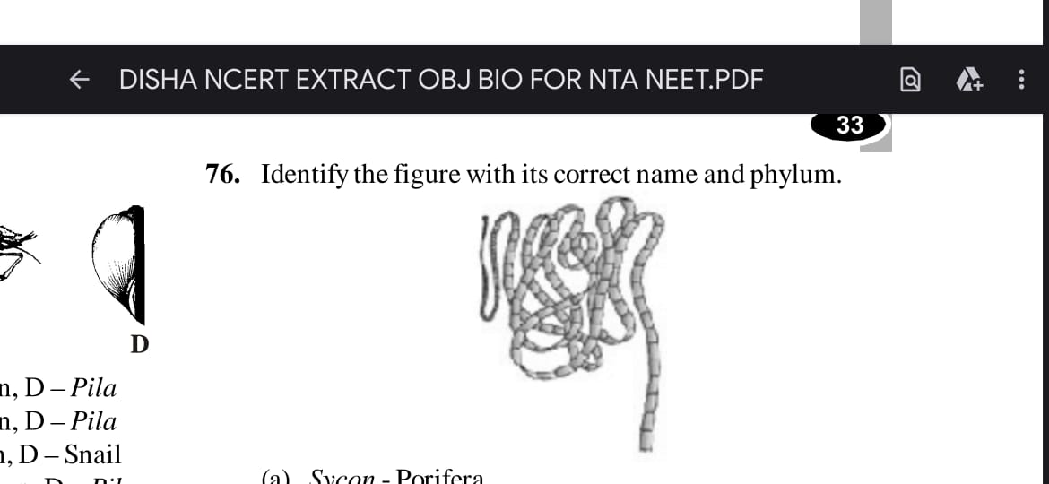

|  |  |
| --- | --- |
| a) Sycon – Porifera | b) Aurelia – Coelenterata |
| c) Pleurobrachia – Ctenophora | d) Tapeworm – Platyhelminthes |

ANIMAL KINGDOM Page No. 4

1. Acoelomate animal with flame cells are :

|  |  |  |  |
| --- | --- | --- | --- |
| a) Platyhelminthes | b) Annelida | c) Aschelminthes | d) Arthropoda |

1. Refer the given figures A, B, C and D and identify the option which shows their correct name.

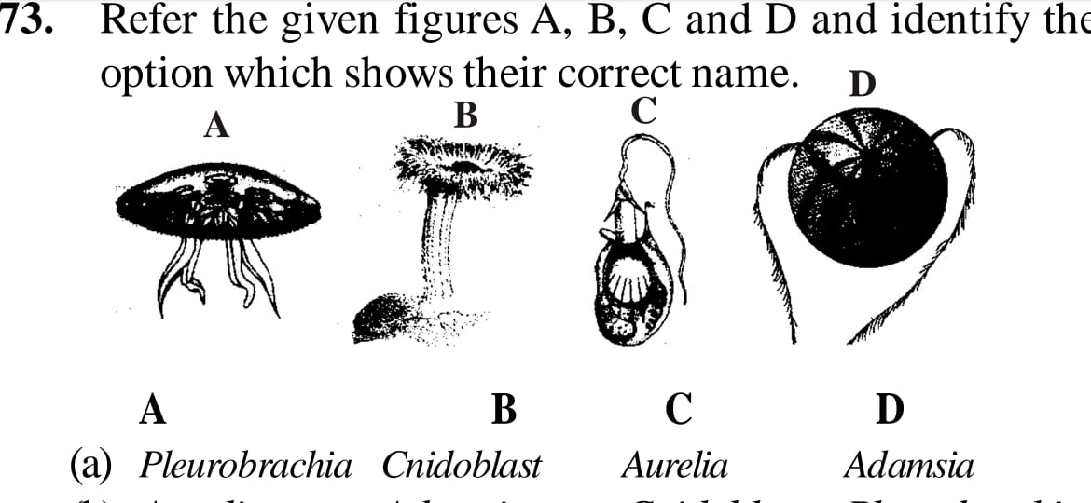

|  |  |  |  |  |
| --- | --- | --- | --- | --- |
|  | A | B | C | D |
| (a) | Pleurobrachia | Cnidoblast | Aurelia | Adamsia |
| (b) | Aurelia | Adamsia | Cnidoblast | Pleurobrachia |
| (c) | Cnidoblast | Pleurobrachia | Adamsia | Aurelia |
| (d) | Adamsia | Aurelia | Pleurobrachia | Cnidoblast |

1. The given figures represent few examples of phylum Porifera. Identify the correct name of the figures.

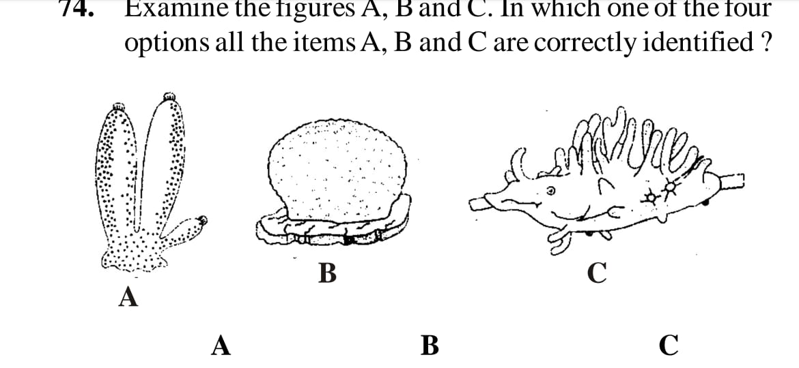

|  |  |  |  |
| --- | --- | --- | --- |
|  | A | B | C |
| (a) | Sycon | Euspongia | Spongilla |
| (b) | Euspongia | Spongilla | Sycon |
| (c) | Spongilla | Sycon | Euspongia |
| (d) | Euspongia | Sycon | Spongilla |

ANIMAL KINGDOM Page No. 5

1. The following diagram shows the germ layer. The animals having structures shows in figures ‘A’ and ‘B’ are respectively called as:

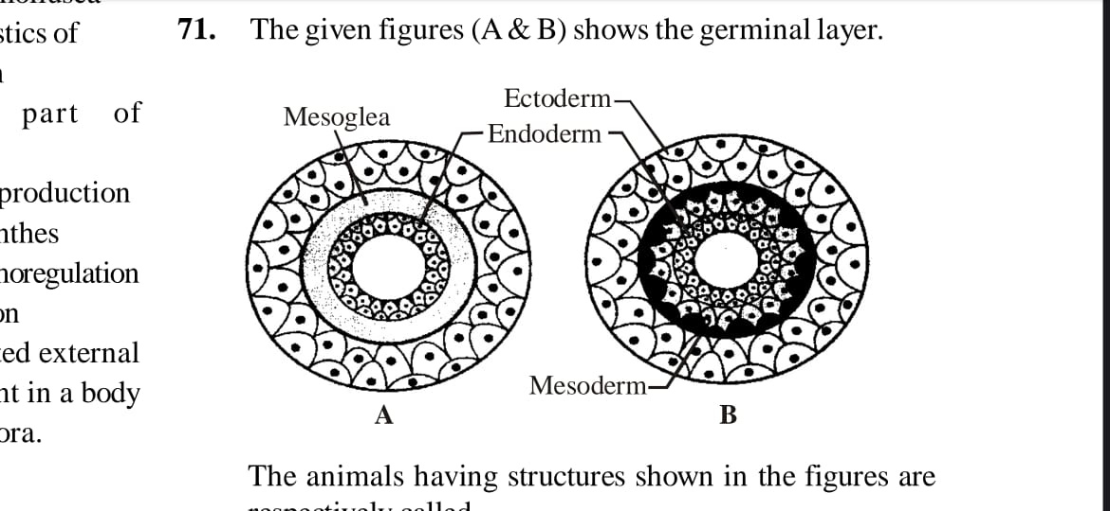

|  |  |
| --- | --- |
| a) Diploblastic , Triploblastic | b) Triploblastic , Diploblastic |
| c) Diploblastic , Diploblastic | d) Triploblastic , Triploblastic |

1. Identify figure and select correct option :

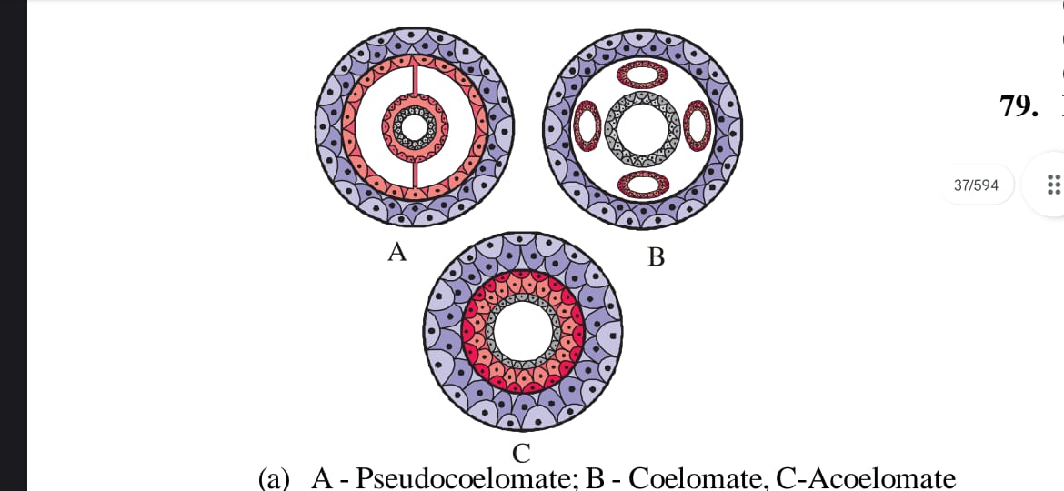

|  |  |  |  |
| --- | --- | --- | --- |
|  | A | B | C |
| (a) | Pseudocoelomate | Coelomate | Acoelomate |
| (b) | Coelomate | Pseudocoelomate | Acoelomate |
| (c) | Coelomate | Acoelomate | Pseudocoelomate |
| (d) | Coelomate | Acoelomate | Eucoelomate |

ANIMAL KINGDOM Page No. 6

**Answers**

|  |  |  |  |  |  |  |  |
| --- | --- | --- | --- | --- | --- | --- | --- |
| 1. a | 1. b | 1. a | 1. d | 1. c | 1. a | 1. c | 1. c |
| 1. c | 1. a | 1. c | 1. d | 1. c | 1. b | 1. c | 1. d |
| 1. d | 1. a | 1. c | 1. c | 1. b | 1. a | 1. d | 1. d |
| 1. c | 1. a | 1. b | 1. a | 1. a | 1. d | 1. b | 1. b |
| 1. a | 1. a | 1. b | 1. a | 1. d | 1. a | 1. b | 1. a |
| 1. a | 1. b |  |  |  |  |  |  |

ANIMAL KINGDOM Page No. 7

|  |
| --- |
| **Neha Malhotra**  **R.L. Institute M: 9416974837**  **Class : XI**  **“ANIMAL KINGDOM”** |

**Level – 2**

**(Based on Annelida , Arthropoda , Mollusca , Echinodermata , Hemichordata & Chordata Phylum)**

1. Annelida are :

|  |  |  |  |
| --- | --- | --- | --- |
| a) radially symmetrical | b) externally symmetrical | c) triploblastic | d) Pseudocoelomate |

1. Body cavity in members of annelids are :

|  |  |  |  |
| --- | --- | --- | --- |
| a) Schizocoel | b) Pseudocoel | c) Enterocoel | d) None of these |

1. Animals of which phylum exhibit ‘tube with in tube’ structure?

|  |  |  |  |
| --- | --- | --- | --- |
| a) Coelenterate | b) Platyhelminthes | c) Porifera | d) Annelida |

1. In animals of which class, the number of body segments is definite?

|  |  |  |  |
| --- | --- | --- | --- |
| a) Oligochaete | b) Hirudinea | c) Polychaeta | d) none of these |

1. Trait common amongst earthworm, leech are :

|  |  |  |  |
| --- | --- | --- | --- |
| a) Absence of legs | b) Hermaphrodite | c) ventral nerve cord | d) Malpighian tubules |

1. Which of the following group of animals belongs to the same phylum?

|  |  |
| --- | --- |
| a) earthworm , pinworm and tapeworm | b) Prawn , scorpion and locusta |
| c) Sponge , sea anemone and starfish | d) Malarial parasite , Amoeba and mosquito |

1. Ascarias is characterized by :
2. Presence of true coelom but absence of metamerism
3. Presence of true coelom and metamerism
4. Absence of true coelom but presence of metamerism
5. Presence of neither true coelom nor metamerism
6. Excretion in Arthropoda take place by :

|  |  |  |  |
| --- | --- | --- | --- |
| a) Malpighian tubules | b) green gland | c) Coxal glands | d) all of these |

1. Which of the following characteristics is shared by all arthropods?

|  |  |
| --- | --- |
| a) complete metamorphosis | b) wings |
| c) jointed appendages | d) asexual reproduction |

1. The presence of compound eyes is the characteristics of phylum _________.

|  |  |  |  |
| --- | --- | --- | --- |
| a) Nematoda | b) Mollusca | c) Echinodermata | d) Arthropoda |

ANIMAL KINGDOM Page No. 8

1. Which one of the following features is common in silver fish , scorpion , dragonfly and prawn?
2. Three pairs of legs and segmented body.
3. Chitinious cuticle and two pairs of antennae.
4. Jointed appendages and Chitinious exoskeleton.
5. Cephalothorax and tracheae
6. A student has identified a triploblastic coelomate segmented animal as an arthropod. Which additional character the student should have verified before identifying that animal as an arthropod?

|  |  |  |  |
| --- | --- | --- | --- |
| a) Presence of wings | b) presence of antennae | c) Type of coelom | d) Type of symmetry |

1. Absence of head, unsegmented body and exoskeleton of dermal calcareous plate are the characters of :

|  |  |  |  |
| --- | --- | --- | --- |
| a) Mollusca | b) Arthropoda | c) Echinodermata | d) none of these |

1. Members of Echinoderm has a specific system, which is not found in other phylum. Identify the system.

|  |  |
| --- | --- |
| a) canal system | b) Water vascular system |
| c) respiratory system | d) Reproductive system |

1. Which of the following is found in both coelenterates and echinoderms in adult stage?

|  |  |  |  |
| --- | --- | --- | --- |
| a) coelenteron | b) radial symmetry | c) Tube-feet | d) Bilateral symmetry |

1. Which of the following characters is incorrect for phylum Chordata?
2. Presence of notochord
3. Presence of vertebral column
4. Paired gill slits
5. A central nervous system dorsal to digestive canal
6. Which of the following is a chordate feature and not shared by non-chordates?

|  |  |  |  |
| --- | --- | --- | --- |
| a) Metamerism | b) axial organisation | c) Bilateral symmetry | d) Pharyngeal gill slits |

1. Which of the following group of phylum belongs to Deuterostome?

|  |  |
| --- | --- |
| a) Annelida , Arthropoda , Mollusca | b) Echinodermata , Hemichordata , Chordata |
| c) Annelida , Mollusca , Chordata | d) Arthropoda , Mollusca , Echinodermata |

1. Hemichordata have now been placed with the non-chordates, close to echinoderms, because true :

|  |  |
| --- | --- |
| a) notochord is absent | b) pharyngeal gill-slits are lacking |
| c) dorsal nerve cord is absent | d) Heart is lacking |

1. Which of the following characteristics distinguish Arthropoda from annelids and molluscs?
2. An external skeleton made up of chitin and protein rather than a shell made chiefly of mineral salts.
3. subdivisions of the legs into movable segments.
4. Distinct group of muscles, derived from many body segments, that move the separate parts of exoskeleton.
5. all the above
6. Refer the following animals and identify those have a fluid filled body cavity with a complete lining derived from mesoderm.

(i) Sycon (ii) Butterfly (iii) Nereis (iv) Sea fan (v) Scorpion (vi) Pila

|  |  |  |  |
| --- | --- | --- | --- |
| a) (i) , (iii) | b) (ii) , (iv) | c) (ii) , (iii) , (iv) , (vi) | d) all the above |

ANIMAL KINGDOM Page No. 9

1. A common characteristics of all vertebrates without exception is :
2. The division of body into head , neck , trunk and tail.
3. Body covered by exoskeleton
4. The possession of two pairs of functional appendages
5. The presence of well-developed skull
6. A student was given a specimen to identify on the basis of characters given below. Identify the specimen.
7. They are metamerically segmented
8. They have closed circulatory system
9. They have circular and longitudinal muscles for locomotion.

|  |  |  |  |
| --- | --- | --- | --- |
| a) Prawn | b) Pheretima | c) Wuchereria | d) Ctenoplana |

1. Match column I and column II

|  |  |  |
| --- | --- | --- |
| Column I | Column II | |
| A. Pennatula | I. Sea-lily | |
| B. Antendon | II. Sea-pen | |
| C. Echinus | III. Sea-urchin | |
| D. Cucumaria | IV. Sea-cucumaria | |
| a) A – II ; B – III ; C – I ; D – IV | | | b) A – II ; B – IV ; C – I ; D – III | |
| c) A – II ; B – I ; C – III ; D – IV | | | d) A – II ; B – I ; C – IV ; D – III | |

1. Which of the following is a correct match of a phylum with three examples?
2. Platyhelminthes – Planaria , Schistsoma , Enterobius
3. Mollusca – Loligo , Sepia , Octopus
4. Porifera – Spongilla , Euplectella , Pennatula
5. Cnidaria – Bonellia , Physalia , Aurelia
6. Match column I and column II

|  |  |  |
| --- | --- | --- |
| Column I | Column II | |
| A. Millipedes | I. Round worm, Pseudocoelomate | |
| B. Ascarias | II. Diplopoda | | |
| C. Asterias | III. Soft body animals, mantle | |
| D. Hirudinaria | IV. Radial symmetry, water vascular system | |
| E. Pila | V. Botryoidal tissues, Temporary clitellum | |
| a) A – II ; B – I ; C – IV ; D – V ; E – III | | | b) A – II ; B – I ; C – IV ; D – III ; E – V | | |
| c) A – II ; B – IV ; C – I ; D – V ; E – III | | | d) A – II ; B – I ; C – V ; D – IV ; E – III | | |

1. Which of the following phylum is being described by given statements?
2. They are bilaterally symmetrical , Triploblastic , segmented and coelomate animals.
3. The body consists of head, thorax , abdomen and have jointed appendages.
4. Circulatory system is open type
5. Excretion takes place by Malpighian tubules.

|  |  |  |  |
| --- | --- | --- | --- |
| a) Arthropoda | b) Annelida | c) mollusca | d) Echinodermata |

ANIMAL KINGDOM Page No. 10

1. Match column I and column II

|  |  |  |  |
| --- | --- | --- | --- |
| Column I | Column II | | |
| A. Water canal system | I. Sponges | | |
| B. Comb plates | II. Help in swimming | |
| C. Nephridia | III. Present in Mollusca | | |
| D. Jointed appendages | IV. Characteristics of round worm | | |
| E. Muscular foot | V. A body part of Arthropoda | | |
|  | VI. Help in reproduction | | |
|  | VII. Platyhelminthes | | |
|  | VIII. Help in excretion and osmoregulation | | |
|  | IX. 8 ciliated external rows present in a body of Ctenophora | | |
|  |  | | |
| a) A – I ; B – IX ; C – VIII ; D – V ; E – III | | | b) A – II ; B – III ; C – VI ; D – I ; E – V | | |
| c) A – II ; B – V ; C – I ; D – IV ; E – IX | | | d) A – III ; B – VI ; C – IV ; D – V ; E – I | | |

1. Which of the following statements is incorrect?
2. Circulatory system in Arthropoda is of closed type
3. Parapodia in annelids helps in swimming.
4. Phylum mollusca is the second largest animal phylum.
5. Aschelminthes are dioecious.

|  |  |  |  |
| --- | --- | --- | --- |
| a) (i) | b) (iii) | c) (i) and (iii) | d) (iii) and (iv) |

1. Match column I and column II

|  |  |  |
| --- | --- | --- |
| Column I | Column II | |
| A. Cockroach | I. Nephridia | |
| B. Cat fish | II. Malpighian tubules | | |
| C. Earthworm | III. Kidneys | |
| D. Balanoglossus | IV. Flame cells | |
| E. Flatworm | V. Proboscis gland | |
| a) A – I ; B – III ; C – II ; D – IV ; E – V | | | b) A – III ; B – I ; C – IV ; D – V ; E – II | | |
| c) A – II ; B – I ; C – IV ; D – V ; E – III | | | d) A – II ; B – III ; C – I ; D – IV ; E – IV | | |

1. Which of the following statement is incorrect?
2. Platyhelminthes has incomplete digestive system
3. In coelenterates, the arrangement of cells is more complex.
4. Nereis is monoecious but earthworm and leeches are dioecious.
5. Simple and compound eyes are present in the animals of those phylum whose over two-thirds of all named species on earth are arthropods.

ANIMAL KINGDOM Page No. 11

1. Match column I and column II

|  |  |  |
| --- | --- | --- |
| Column I | Column II | |
| A. Choanocytes | I. Platyhelminthes | |
| B. Cnidoblast | II. Ctenophora | | |
| C. Flame cell | III. Porifera | |
| D. Nephridia | IV. Coelenterate | |
| E. Comb plates | V. Annelida | |
| a) A – II ; B – I ; C – IV ; D – V ; E – III | | | b) A – II ; B – IV ; C – I ; D – V ; E – III | | |
| c) A – V ; B – I ; C – III ; D – II ; E – IV | | | d) A – III ; B – IV ; C – I ; D – V ; E – II | | |

1. Which of the following statements are incorrect?
2. Parapodia are lateral appendages in arthropods used for swimming.
3. Radula is molluscs are structures involved in excretion.
4. Aschelminthes are dioecious
5. Echinoderm adults show radial symmetry
6. Ctenophorans are diploblastic.

|  |  |  |  |
| --- | --- | --- | --- |
| a) (i) , (ii) | b) (i) , (iii) | c) (i) , (iv) , (v) | d) (iii) and (v) |

1. Match column I and column II

|  |  |  |
| --- | --- | --- |
| Column I | Column II | |
| A. Gregarious pest | I. Hirudinaria | |
| B. Vector | II. Planaria | | |
| C. Oviparous with indirect development | III. Sepia | |
| D. Metameres | IV. Aedes | |
| E. High regeneration capacity | V. Locust | |
| a) A – I ; B – II ; C – III ; D – IV ; E – V | | | b) A – III ; B – V ; C – II ; D – IV ; E – I | | |
| c) A – III ; B – I ; C – V ; D – II ; E – IV | | | d) A – V ; B – IV ; C – III ; D – I ; E – II | | |

1. which of the following statements is/are correct regarding phylum mollusca?
2. They are bilaterally symmetrical, triploblastic and coelomate animals.
3. Body is covered by a calcareous shell and is unsegmented with a distinct head, muscular foot and visceral hump.
4. The mouth contains a file like rasping organ for feeding called radula.
5. all of the above.
6. Which of the following statements is incorrect?
7. In Urochordates, notochord is present only in larva tail.
8. In Cephalochordates , notochord extends from head to tail region.
9. Branchiostoma belongs to Hemichordata.
10. Only one class of living members, class cyclostomata represents the super class agnatha.

|  |  |  |  |
| --- | --- | --- | --- |
| a) (i) , (ii) , (iv) | b) (iii) , (iv) , (i) | c) (iii) | d) (i) , (iv) |

ANIMAL KINGDOM Page No. 12

1. Match column I and column II

|  |  |  |
| --- | --- | --- |
| Column I | Column II | |
| A. Echinodermata | I. Ascidia , Doliodum | |
| B. Hemichordata | II. Asterias , Ophiura | |
| C. Urochordata | III. Branchiostoma | |
| D. Cephalochordata | IV. Balanoglossus , Saccoglossus | |
| a) A – IV ; B – II ; C – I ; D – III | | | b) A – II ; B – IV ; C – I ; D – III | |
| c) A – II ; B – IV ; C – III ; D – I | | | d) A – II ; B – I ; C – IV ; D – III | |

1. Match column I and column II

|  |  |  |
| --- | --- | --- |
| Column I | Column II | |
| A. Pila | I. Flame cell | |
| B. Bombyx | II. Comb plates | |
| C. Pleurobrachia | III. Radula | |
| D. Taenia | IV. Malpighian tubules | |
| a) A – III ; B – II ; C – I ; D – IV | | | b) A – III ; B – IV ; C – II ; D – I | |
| c) A – II ; B – IV ; C – III ; D – I | | | d) A – III ; B – II ; C – IV ; D – I | |

1. An important characteristics that hemichordates share with chordates is :

|  |  |
| --- | --- |
| a) Ventral tubular nerve cord | b) Pharynx with gill slits |
| c) Pharynx without gill slits | d) absence of notochord |

1. Which of the following features is not present in phylum Arthropoda?

|  |  |
| --- | --- |
| a) Chitinious exoskeleton | b) Metameric segmentation |
| c) Parapodia | d) joint appendages |

1. which of the following characteristics is mainly responsible for diversification of insects on land?

|  |  |  |  |
| --- | --- | --- | --- |
| a) bilateral symmetry | b) Exoskeleton | c) Eyes | d) Segmentation |

1. Which one of the following have the highest number of species in nature?

|  |  |  |  |
| --- | --- | --- | --- |
| a) Fungi | b) insects | c) Birds | d) Angiosperms |

1. Which of the following statements about certain given animals is correct?

|  |  |
| --- | --- |
| a) Round worm are Pseudocoelomates | b) Molluscs are acoelomates |
| c) Insects are Pseudocoelomates | d) Flatworm are coelomates |

1. One example of animals having a single opening to the outside that serves both mouth as well as anus is :

|  |  |  |  |
| --- | --- | --- | --- |
| a) octopus | b) Asterias | c) Ascidia | d) Fasciola |

1. Select the correct matching .

|  |  |  |  |
| --- | --- | --- | --- |
|  | Phylum | Character | Example |
| (a) | Hemichordata | Notochord | Balanoglossus |
| (b) | Mollusca | Radula | Dentalium |
| (c) | Platyhelminthes | Coelomate | Dugesia |
| (d) | Coelenterate | All marine | Hydra |

ANIMAL KINGDOM Page No. 13

1. Find out the correct option about Coelenterata.

|  |  |
| --- | --- |
| a) Cnidoblast and bilateral symmetry | b) Cnidoblast and water canal system |
| c) Choanocytes and water canal system | d) All marine and only sexual reproduction occur |

1. Which of the following are true about Mollusca?

|  |  |
| --- | --- |
| a) Triploblastic and radial symmetry | b) Bilateral symmetry |
| c) Radula and diploblastic | d) Calcareous shell and radial symmetry |

1. Cockroach are brown or black bodied animals that are included in class _______ of phylum __________.

|  |  |
| --- | --- |
| a) Reptilia ; Annelida | b) Insecta ; Arthropoda |
| c) Insecta ; Annelida | d) Reptilia ; Arthropoda |

1. Which of the following options shows the correct name of the animals shown by the given figures A , B , C and D?

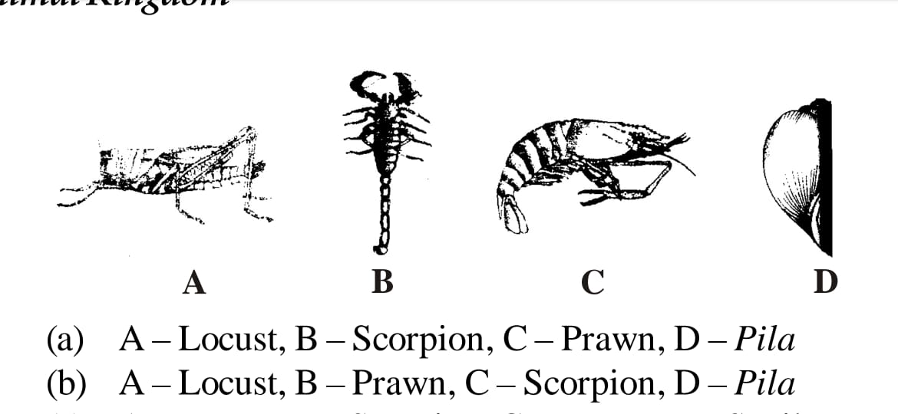

|  |  |
| --- | --- |
| a) A – Locust ; B – Scorpion ; C – Prawn ; D – Pila | b) A – Locust ; B – Prawn ; C – Scorpion ; D – Pila |
| c) A – Locust ; B – Scorpion ; C – Prawn ; D – Snail | d) A – Butterfly ; B – Scorpion ; C – Prawn ; D – Pila |

1. identify the figures A , B and C and choose the correct option.

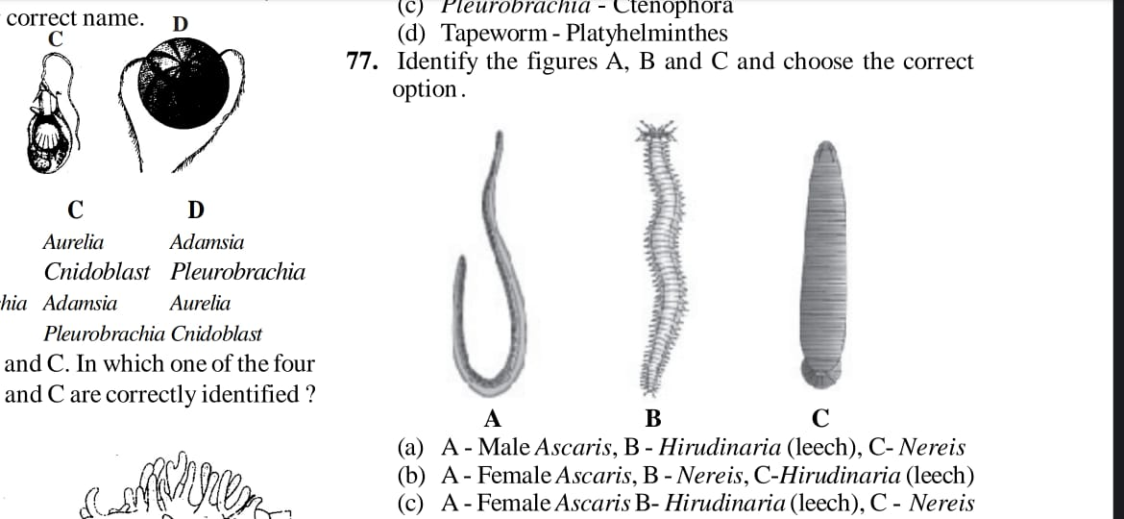

|  |  |
| --- | --- |
| a) A – Male Ascarias ; B – Hirudinaria ; C – Nereis | b) A – Female Ascarias ; B – Nereis ; C – Hirudinaria |
| c) A – Female Ascarias ; B – Hirudinaria ; C – Nereis | d) A – Male Ascarias ; B – Nereis ; C – Hirudinaria |

1. Identify the animals shown in given figures A and B from options given below.

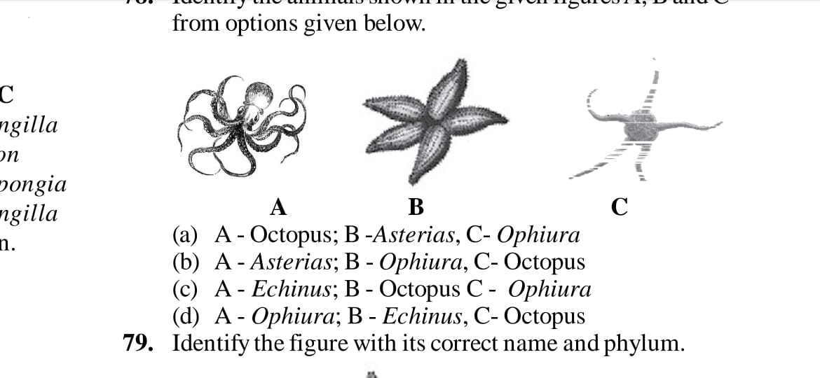

|  |  |
| --- | --- |
| a) A – Octopus ; B – Asterias ; C – Ophiura | b) A – Asterias ; B – Ophiura ; C – Octopus |
| c) A – Echinus ; B – Octopus ; C – Ophiura | d) A – Ophiura ; B – Echinus ; C – Octopus |

ANIMAL KINGDOM Page No. 14

1. Identify the figure with its correct name and phylum .

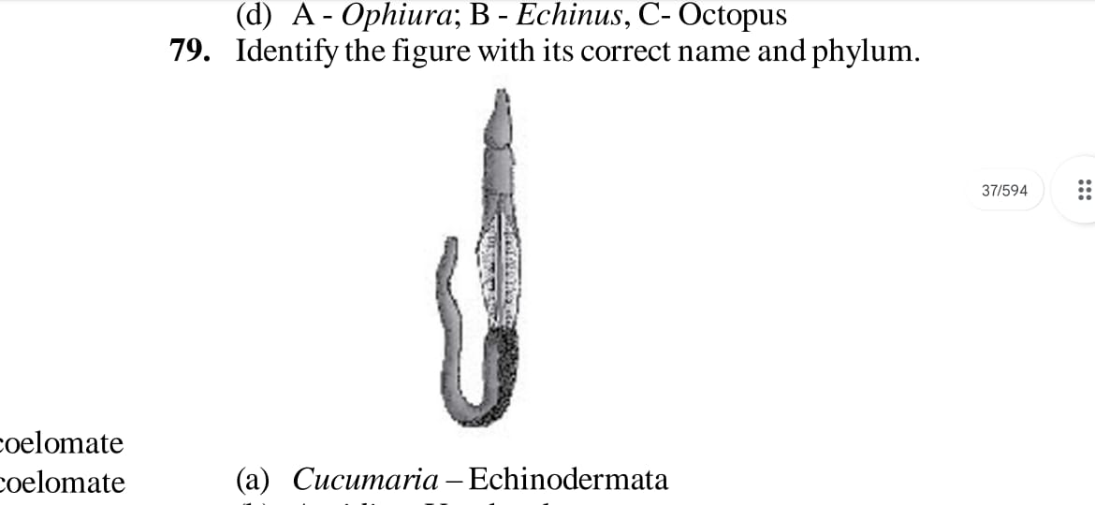

|  |  |
| --- | --- |
| a) Cucumaria – Echinodermata | b) Ascidia – Urochordata |
| c) Balanoglossus – Hemichordata | d) Hirudinaria – Annelida |

1. The given figure shows characteristics features of chordates marked as A , B , C and D. Identify the correct labelling:

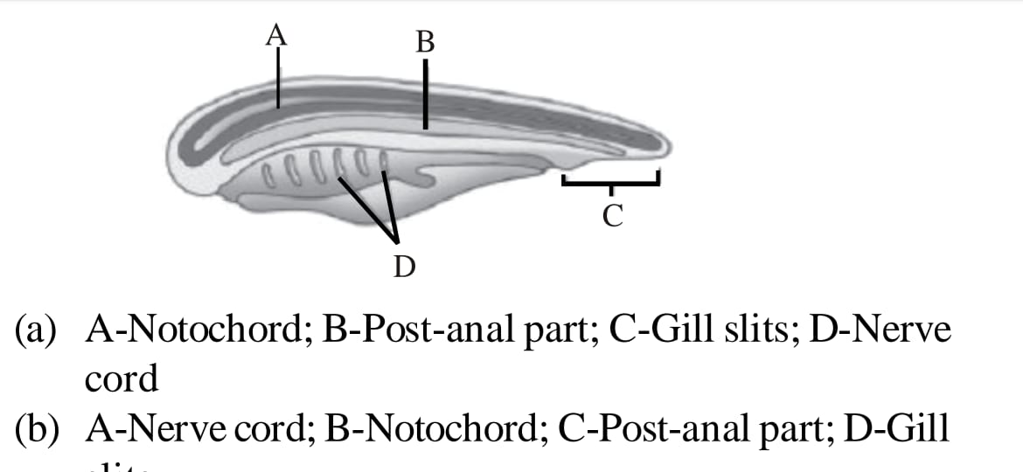

1. A – Anal cord ; B – Post anal part ; C – Gill slits ; D – Nerve cord
2. A – Nerve cord ; B – Notochord ; C – Post anal part ; D – Gill slits
3. A – Notochord ; B – Nerve cord ; C – Gill slits ; D – Post anal part
4. A – Gill slits ; B – Post anal part ; C – Nerve cord ; D – Notochord

ANIMAL KINGDOM Page No. 15

**Answers**

|  |  |  |  |  |  |  |  |
| --- | --- | --- | --- | --- | --- | --- | --- |
| 1. c | 1. a | 1. d | 1. b | 1. c | 1. b | 1. d | 1. d |
| 1. c | 1. d | 1. c | 1. b | 1. c | 1. b | 1. b | 1. b |
| 1. d | 1. b | 1. a | 1. d | 1. c | 1. d | 1. b | 1. c |
| 1. b | 1. a | 1. a | 1. a | 1. a | 1. d | 1. c | 1. d |
| 1. a | 1. d | 1. d | 1. c | 1. b | 1. b | 1. b | 1. b |
| 1. b | 1. b | 1. a | 1. d | 1. b | 1. b | 1. b | 1. b |
| 1. a | 1. b | 1. a | 1. c | 1. b |  |  |  |

ANIMAL KINGDOM Page No. 16

|  |
| --- |
| **Neha Malhotra**  **R.L. Institute M: 9416974837**  **Class : XI**  **“ANIMAL KINGDOM”** |

**Level – 3**

**(Based on Chordata Classes)**

1. Which of the following are characteristics features of fishes?

|  |  |
| --- | --- |
| a) Tail and Venous heart | b) Venous heart and gills |
| c) Epidermal scales and tail | d) Epidermal scales and gills |

1. Heart of fishes is :

|  |  |  |  |
| --- | --- | --- | --- |
| a) 1 chambered | b) 2 chambered | c) 3 chambered | d) 4 chambered |

1. Which one of the following is a cartilaginous fish?

|  |  |  |  |
| --- | --- | --- | --- |
| a) silver fish | b) dog fish | c) Cray fish | d) star fish |

1. Jaws are absent in :

|  |  |
| --- | --- |
| a) Protochordata | b) Protochordata and cyclostomata |
| c) Amphioxus and Balanoglossus | d) Herdmania and Myxine |

1. Scales in Chondrichthyes are :

|  |  |  |  |
| --- | --- | --- | --- |
| a) Placoid | b) Ganoid | c) Cycloid | d) Sesamoid |

1. Gambusia is a :

|  |  |
| --- | --- |
| a) parasitic fish | b) Pest of fish |
| c) fish predator of mosquitos larva | d) Mosquito spreading yellow fever |

1. An indigenous fish used in biological control is :

|  |  |  |  |
| --- | --- | --- | --- |
| a) *Catla* | b) *Labestes* | c) *Gambusia* | d) *Aplocheilus* |

1. Electric organs occur in :

|  |  |  |  |
| --- | --- | --- | --- |
| a) Sharks | b) Goldfish | c) Porpoises | d) Rays |

1. Scoliodon is called dog fish because of its :

|  |  |  |  |
| --- | --- | --- | --- |
| a) Carnivorous nature | b) Long mouth | c) Power of smell | d) all of these |

1. Which of the following statement is correct for mammalia?

|  |  |
| --- | --- |
| a) Platypus is oviparous | b) Bats have feather. |
| c) elephant is an ovo-viviparous | d) Diaphragm is absent in them |

1. In which of the following animals, post anal tail is found?

|  |  |  |  |
| --- | --- | --- | --- |
| a) earthworm | b) lower invertebrates | c) scorpion | d) Snake |

ANIMAL KINGDOM Page No. 17

1. Which one of the following is a very unique feature of the mammalian body?

|  |  |
| --- | --- |
| a) presence of diaphragm | b) 4 chambered heart |
| c) rib cage | d) Homeothermy |

1. An egg laying mammal is :

|  |  |  |  |
| --- | --- | --- | --- |
| a) Kangaroo | b) Platypus | c) Koala | d) whale |

1. Which one of the following snake is not poisonous?

|  |  |  |  |
| --- | --- | --- | --- |
| a) Naja-naja | b) Python | c) Bungarus | d) Hydophis |

1. Which of the following is not found in birds?

|  |  |  |  |
| --- | --- | --- | --- |
| a) Hind limb | b) Fore limb | c) Pelvic girdle | d) Pectoral girdle |

1. Urinary bladder is absent in :

|  |  |  |  |
| --- | --- | --- | --- |
| a) Amphibians | b) mammals | c) Both (a) and (b) | d) Aves |

1. Which animal belong to class mammalia?

|  |  |  |  |
| --- | --- | --- | --- |
| a) Platypus | b) Columba | c) Testudo | d) Chameleon |

1. Which of the following is correct?
2. Cyclostomes have a sucking and circular mouth without jaws.
3. Cyclostomes are fresh water but migrate to marine water for spawning.
4. Osteicthyes are mostly oviparous and development is direct.
5. In Chondrichthyes , notochord is persistent throughout life.
6. Which of the following statement is/are correct for class amphibian?
7. Body is divisible into head and trunk
8. Respiration is through gills only.
9. The heart is 2 chambered
10. Fertilization is internal.

|  |  |  |  |
| --- | --- | --- | --- |
| a) (i) | b) (iv) | c) (i) , (ii) and (iii) | d) all of these |

1. Which of the following characteristics is correct for Reptilia?
2. Body covered with dry and cornified skin, scales over the body are epidermal, they do not have external ears
3. Body is covered with moist skin and is devoid of scales, the ear is represented by a tympanum, alimentary canal, urinary bladder and reproductive tracts open into a common cloaca.
4. Fresh water animals, with bony endoskeleton and air bladder regulate buoyancy.
5. Marine animals with cartilaginous endoskeleton and body is covered with Placoid scales.
6. Which of the following statements is/are correct regarding class Aves?
7. The forelimbs are modified into wings and the hind-limbs generally have scales and are modifies for walking, swimming or clasping the tree branches.
8. Heart is completely 4 chambered
9. They are warm-blooded animals
10. They are oviparous and development is direct.

|  |  |  |  |
| --- | --- | --- | --- |
| a) (i) , (iii) | b) (i) , (iv) | c) (i) , (ii) , (iii) | d) all of these |

ANIMAL KINGDOM Page No. 18

1. Match column I and column II

|  |  |  |
| --- | --- | --- |
| Column I | Column II | |
| A. Limbless reptiles | I. Elephant | |
| B. Jawless vertebrates | II. Lamprey | | |
| C. Flightless bird | III. Ichthyophis | |
| D. Largest terrestrial animal | IV. Ostrich | |
| E. Blind worm | V. Cobra | |
|  | VI. Penguin | |
| a) A – II ; B – V ; C – IV ; D – I ; E – III | | | b) A – V ; B – II ; C – IV ; D – I ; E – III | | |
| c) A – V ; B – II ; C – I ; D – IV ; E – III | | | d) A – V ; B – IV ; C – II ; D – I ; E – III | | |

1. Which of the following class is being described by the given statements?
2. They are found in a variety of habitats – polar ice-caps , deserts , mountains , forests , grasslands and dark caves.
3. Most unique characteristics is the presence of mammary gland by which the young ones are nourished.
4. Heart is four chambered
5. Sexes are separate and fertilization is internal.

|  |  |  |  |
| --- | --- | --- | --- |
| a) Reptilia | b) Aves | c) Mammalia | d) Amphibia |

1. Match column I and column II

|  |  |  |
| --- | --- | --- |
| Column I | Column II | |
| A. Limbless reptiles | I. Lamprey | |
| B. Jawless vertebrates | II. Salamander | | |
| C. Amphibians | III. Snake | |
| D. Cartilaginous fish | IV. Shark | |
| E. Flightless bird | V. Ostrich | |
| a) A – I ; B – II ; C – III ; D – IV ; E – V | | | b) A – II ; B – I ; C – III ; D – IV ; E – V | | |
| c) A – III ; B – I ; C – II ; D – IV ; E – V | | | d) A – IV ; B – II ; C – III ; D – I ; E – V | | |

1. Which one of these animals is not a homeotherm?

|  |  |  |  |
| --- | --- | --- | --- |
| a) Macropus | b) Chelone | c) Psittacula | d) Camelus |

1. Identify the vertebrate group of animals characterized by crop and gizzard in its digestive system.

|  |  |  |  |
| --- | --- | --- | --- |
| a) Amphibia | b) Reptilia | c) Osteichthyes | d) Aves |

1. Which of the following characteristics features always holds true for the corresponding group of animals?
2. Cartilaginous exoskeleton – Chondrichthyes
3. Viviparous – Mammalia
4. Possess a mouth with an upper and a lower jaw – Chordata
5. 3 chambered heart with one incompletely divided ventricle – Reptilia
6. Which one of the following characteristics is not shared by birds and mammals?

|  |  |
| --- | --- |
| a) Ossified endoskeleton | b) Breathing using lungs |
| c) Viviparity | d) Warm blooded nature |

ANIMAL KINGDOM Page No. 19

1. A jawless fish, which lays eggs in fresh water ad whose ammocoetes larvae after metamorphosis return to the ocean is :

|  |  |  |  |
| --- | --- | --- | --- |
| a) Salpa | b) Neomyxine | c) Petromyzon | d) Eptatretus |

1. Which of the following animals is not viviparous?

|  |  |  |  |
| --- | --- | --- | --- |
| a) Elephant | b) Platypus | c) Whale | d) Flying fox (Bat) |

1. A marine cartilaginous fish that can produce electric current.

|  |  |  |  |
| --- | --- | --- | --- |
| a) Pristis | b) Torpedo | c) Trygon | d) Scoliodon |

1. Match column I , II and II.

|  |  |  |  |
| --- | --- | --- | --- |
|  | Column I | Column II | Column III |
| (a) | Ichthyophis | Terrestrial | Reptilia |
| (b) | Limulus | Body covered by Chitinious endoskeleton | Pisces |
| (c) | Adamsia | Radially symmetrical | Porifera |
| (d) | Petromyzon | Ectoparasite | Cyclostomata |

1. Which one of the following categories of animals is correctly described with no single exception in it?
2. All sponges are marine and have collared cells.
3. All mammals are viviparous and possess diaphragm for breathing
4. All bony fishes have four pairs of gills and an operculum on each side.
5. All reptiles possess scales, have a 3 chambered heart and are cold blooded.
6. In which one of the following, the genus name, its two characters and its class/phylum are correctly matched?

|  |  |  |  |
| --- | --- | --- | --- |
|  | Genus name | Two characters | Class/Phylum |
| (a) | Ascarias | 1. Body segmented 2. Males and females distinct | Annelida |
| (b) | Salamander | 1. A tympanum represents ear 2. Fertilization is external | Amphibia |
| (c) | Pteropus | 1. Skin possess hair 2. Oviparous | Mammals |
| (d) | Aurelia | 1. Cnidoblast 2. Organ level of organisation | Coelenterata |

1. Which one of the following groups of animals is correctly matched with its one characteristics feature without even a single exception?
2. Reptilia : Possess 3 chambered heart with one incompletely divided ventricle
3. Chordata : Possess a mouth provided with an upper and lower jaw.
4. Chondrichthyes : Possess cartilaginous endoskeleton
5. Mammalia : Give birth to young ones.

ANIMAL KINGDOM Page No. 20

1. What will you look for to identify the sex of the following?
2. Female Ascarias – Sharply curved posterior end
3. Male frog – A copulatory pad on first digit of the hind limb
4. Female cockroach – Anal cerci
5. Male shark – Claspers borne on pelvic fins
6. Which one of the following statements is totally wrong about the occurrence of notochord, while the other three are correct?
7. It is present only in larval tail in Ascidians
8. It is replaced by a vertebral column in adult frog.
9. It is absent throughout life in humans from the very beginning.
10. It is present throughout life in Amphioxus.
11. Which one of the following statements about all the four of Spongilla , leech , Dolphin and Penguin is correct?
12. Penguin is a homoeothermic while the remaining three are poikilothermic.
13. Leech is a fresh water from while all others are marine.
14. Spongilla has special collared cells called Choanocytes not found in the remaining three.
15. All are bilateral symmetrical.
16. Which all belong to the same phylum?
17. Mammalia – Balenoptera , Delphinus , Rattus , Felis
18. Porifera – Euspongilla , Scypha , Pennatula
19. Arthropoda – Crab , Limulus , Aplysia , cockroach
20. Coelenterata – Hydra , Gorgonia , Obelia , Sycon
21. Which of the following is member of subphylum cephalochordate

|  |  |  |  |
| --- | --- | --- | --- |
| a) Branchiostoma | b) Balanoglossus | c) Doliodum | d) Myxine |

1. Which of the following statement is incorrect regarding the cyclostomes?
2. After spawning, with in few days they will die
3. Commonly called as round mouth fishes
4. Their larva migrate from fresh water to marine water
5. Petromyzon is called as Hag fish
6. In cartilage fishes, gills are covered with

|  |  |  |  |
| --- | --- | --- | --- |
| a) Radula | b) Gills slits | c) Operculum | d) No covering |

1. The skin of cartilaginous fish is tough containing minute scales referred as

|  |  |  |  |
| --- | --- | --- | --- |
| a) Cycloid | b) Ctenoid | c) Gannoid | d) Placoid |

1. Air bladder is present in bony fishes, regulates :

|  |  |  |  |
| --- | --- | --- | --- |
| a) Excretion | b) Buoyancy | c) Balance | d) Hearing |

1. The number of gills that present in Osteichthyes is

|  |  |  |  |
| --- | --- | --- | --- |
| a) 2 pairs | b) 6 – 15 pairs | c) 5 pairs | d) 4 pairs |

ANIMAL KINGDOM Page No. 21

1. Match column I and column II

|  |  |
| --- | --- |
| Column I | Column II |
| A. Labeo rohita | I. Flying fish |
| B. Exocoetus | II. Rohu |
| C. Charcharodon | III. Angel fish |
| D. Petrophyllum | IV. Great white shark |

|  |  |
| --- | --- |
| a) A – III ; B – I ; C – IV ; D – II | b) A – II ; B – III ; C – I ; D – IV |
| c) A – II ; B – I ; C – III ; D – IV | d) A – II ; B – I ; C – IV ; D – III |

1. Which of the following is referred as wall lizard?

|  |  |  |  |
| --- | --- | --- | --- |
| a) Alligator | b) Naja | c) Hemidactylus | d) Bangarus |

1. Oil gland on the body of Aves present

|  |  |
| --- | --- |
| a) At the base of beak | b) At the base of forelimbs |
| c) At the base of tail | d) At the base of third limb |

1. Digestive tract of bird is having

|  |  |  |  |
| --- | --- | --- | --- |
| a) Crop | b) Typhlosole | c) Gizzard | d) Both (a) & (c) |

1. The most unique mammalian characteristics is the presence of

|  |  |
| --- | --- |
| a) Dermal scales on body | b) Presence of tails |
| c) Mammary gland | d) Control and co-ordination system |

1. Match column I and column II

|  |  |
| --- | --- |
| Column I | Column II |
| A. Cyclostomes | I. Hemichordata |
| B. Aves | II. Urochordata |
| C. Tunicates | III. Agnatha |
| D. Balanoglossus  E. Osteichthyes | IV. Pisces  V. Tetrapoda |

|  |  |
| --- | --- |
| a) A – I ; B – II ; C – III ; D – IV ; E – V | b) A – II ; B – III ; C – IV ; D – I ; E – V |
| c) A – III ; B – V ; C – II ; D – I ; E – IV | d) A – III ; B – I ; C – V ; D – II ; E – IV |

ANIMAL KINGDOM Page No. 22

**Answers**

|  |  |  |  |  |  |  |  |
| --- | --- | --- | --- | --- | --- | --- | --- |
| 1. b | 1. b | 1. b | 1. b | 1. a | 1. c | 1. c | 1. d |
| 1. c | 1. a | 1. d | 1. a | 1. b | 1. b | 1. b | 1. d |
| 1. a | 1. a | 1. a | 1. a | 1. d | 1. b | 1. c | 1. c |
| 1. b | 1. d | 1. a | 1. c | 1. c | 1. b | 1. b | 1. d |
| 1. a | 1. b | 1. c | 1. d | 1. c | 1. c | 1. a | 1. a |
| 1. d | 1. d | 1. d | 1. b | 1. d | 1. d | 1. c | 1. c |
| 1. d | 1. c | 1. c |  |  |  |  |  |

ANIMAL KINGDOM Page No. 23